# University of Nairobi | Committed to Scholarly Excellence

REG NO: P15/1662/2019

NAME: ASAVA MAJANI LESLIE

DATE: 13/01/2022

PROJECT TITLE: CROWD FACE MASK DETECTION

# CATEGORY SELECTION

I chose **Computer Vision** as my preferred category. This is because I wanted to look deeper into how computers can be made to recognize patterns in visual data through the use of algorithms. This project includes modules for object detection, namely facial detection and image classification both of which are areas of study within computer vision.

# DOMAIN SELECTION

I chose **Health** as my preferred domain. The COVID-19 pandemic has been raging on for more than a year now and the government has been consistently trying to keep it under control and slow down its spread.

One of the ways they have tried to do this is by dictating protocols to be followed for example such as mask mandates, social distancing and the use of sanitizers. I felt the need to develop a system to help combat the spread of the virus by aiding in the enforcement of mask mandates.

# PROBLEM DEFINITION

One of the ways in which the government and private organizations in general have tried to combat the spread of COVID-19 is by requiring masks in public areas. The way they have tried to enforce this is by using security guards to deny entry to anyone without a mask.

It is however difficult to ensure that people keep their masks on once inside. Furthermore, monitoring every single person once inside manually is both tedious and time consuming. A better way would be to build an automated system that can easily scan the crowd and alert anyone concerned whenever anyone is ignoring these mask mandates.

I therefore propose a system that would be able to accomplish this using computer vision. I believe this will go a long way to reduce transmission.

# SYSTEM OBJECTIVES

The final system should be able to do the following things;

1. Scan visual data whether from images, videos and live streams and detect whether or not the people present have their masks on
2. Summarize the data in a visual way so that the relevant party is able to act upon the data

# PROJECT JUSTIFICATION

The projects main merit is that it will help institutions easily enforce mask mandates. This will in turn help reduce inter person transmission of COVID-19 within these institutions that would have otherwise occurred had people not been wearing face masks.

The intended users of this system are majorly public institutions prone to aid in the spread of COVID-19 due high inter-person interaction. These institutions include;

1. Schools
2. Hospitals
3. Government institutions
4. Offices

# PAST WORK

Concepts used to develop this system have existed previously. Among these are facial detection which is an AI based technique used to find and identify human faces in images. Facial detection has progressed rapidly through the years from basic computer vision algorithms to machine learning techniques to use of artificial neural networks.

Image classification is the process of categorizing images with labels based on common patterns. Various techniques have been used over the years for example Support Vector Classifiers and deep learning algorithms.

My project uses face detection to locate faces in images and image classification to detect whether the faces have masks on.

# METHODOLOGY

The Structured Systems Analysis and Design model is used in the development of this project. It is made up of the following phases;

1. **Planning**

In this phase the problem is defined clearly, objectives are formulated and the scope is determined.

1. **System Analysis**

In this phase the gathered requirements are analyzed so as to come up with detailed specifications for the new system. Schedule and operational feasibility studies are also carried out.

1. **System Design**

In this phase, a description of how the system is to be implemented is defined User Interface and Software architecture designs are done here

1. **System Implementation**

This phase involves the actual coding of the software

1. **Testing**

In this phase the software is tested extensively both to eliminate errors and to ensure that it meets the specified requirements

1. **Deployment**

The complete, fully tested software is presented along with the accompanying documentation

# SYSTEM ANALYSIS

## Requirements Analysis

### Functional Requirements

The system should;

1. Allow users to select images to scan from local storage
2. Allow users to select videos to scan from local storage
3. Allow users to scan live video e.g. from a webcam
4. Detect whether there are people in the images
5. Detect whether the people in the images are wearing face masks
6. Display summary stats from the prediction

### Non - Functional Requirements

The system should;

1. Be able to do predictions in real time
2. Correctly handle errors and keep from crashing

## a) Feasibility Study

### Schedule Feasibility

The project is scheduled to be conducted within 3 months starting from the 1st of November 2021 and ending on the 28th of January 2022.

### Operational Feasibility

The final system should be able to analyze images and videos in real-time and detect whether the people present are wearing masks. This is feasible using Python and accompanying libraries

### Technical Feasibility

The only requirements for developing the system is a Personal Computer for coding and testing the system, a Python interpreter, and image dataset all of which are available

### Cost Feasibility

The only hardware requirement for this project is a Personal Computer which is already available. All software required for development is free and open source. The project is therefore feasible in terms of cost.

## b) Evaluation of alternatives

**1. UI Development**

I had various options for UI development namely;

* Streamlit
* PyQt5
* Tkinter
* Kivy
* PySide

I decided to go with PyQt5 since it has a wide range of widgets to choose from and it also has inbuilt threading and signal capabilities that would allow it to run the model in the background. I also had some previous experience using it so it would be easier to develop with.

* 1. **Emotion Recognition Model**

I had the following options for training our plant disease recognition model;

* Tensorflow
* Keras
* Scikit-learn
* PyTorch

I decided to go with Tensorflow since I could easily build and test neural network models with it

# SYSTEM DESIGN

## SYSTEM ARCHITECTURE

Generally, the system receives raw visual data as images, video files or live video streams then performs preprocessing to make them easier to work with. It then performs face detection to locate faces on the images. The next step is to perform image classification on the regions with faces to determine whether or not they are wearing masks. The last step is to present this data to the user in a visual way.

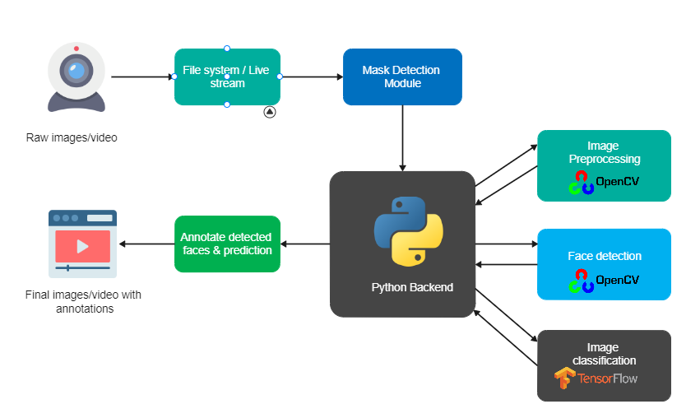

## USER INTERFACE DESIGN

### Image Mask Detection

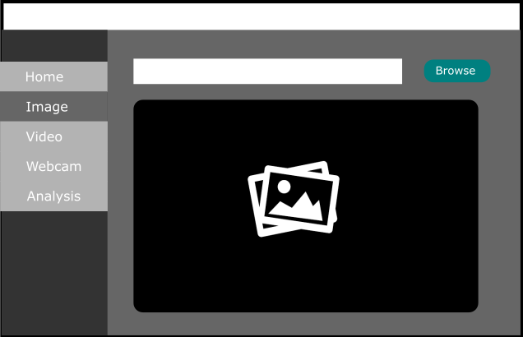

### Data Analysis

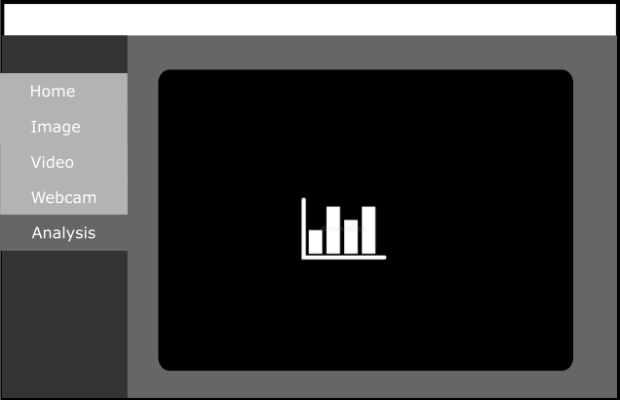

# SYSTEM IMPLEMENTATION

## Overview

The entire system is coded in python with the aid of the following libraries;

1. **Tensorflow** - For image classification to determine whether or not someone is wearing a mask
2. **OpenCV** - For image processing and face detection
3. **Matplotlib** - To plot data in charts
4. **PyQt5 –** For the User Interface

## Model Training

The model used is a neural network model created with tensorflow and trained over 20 epochs on a large dataset with a total of **4,095** images i.e.

* **1930 -** Images of people without masks
* **2165 –** Images of people with masks

## Demonstration

#### Home Screen

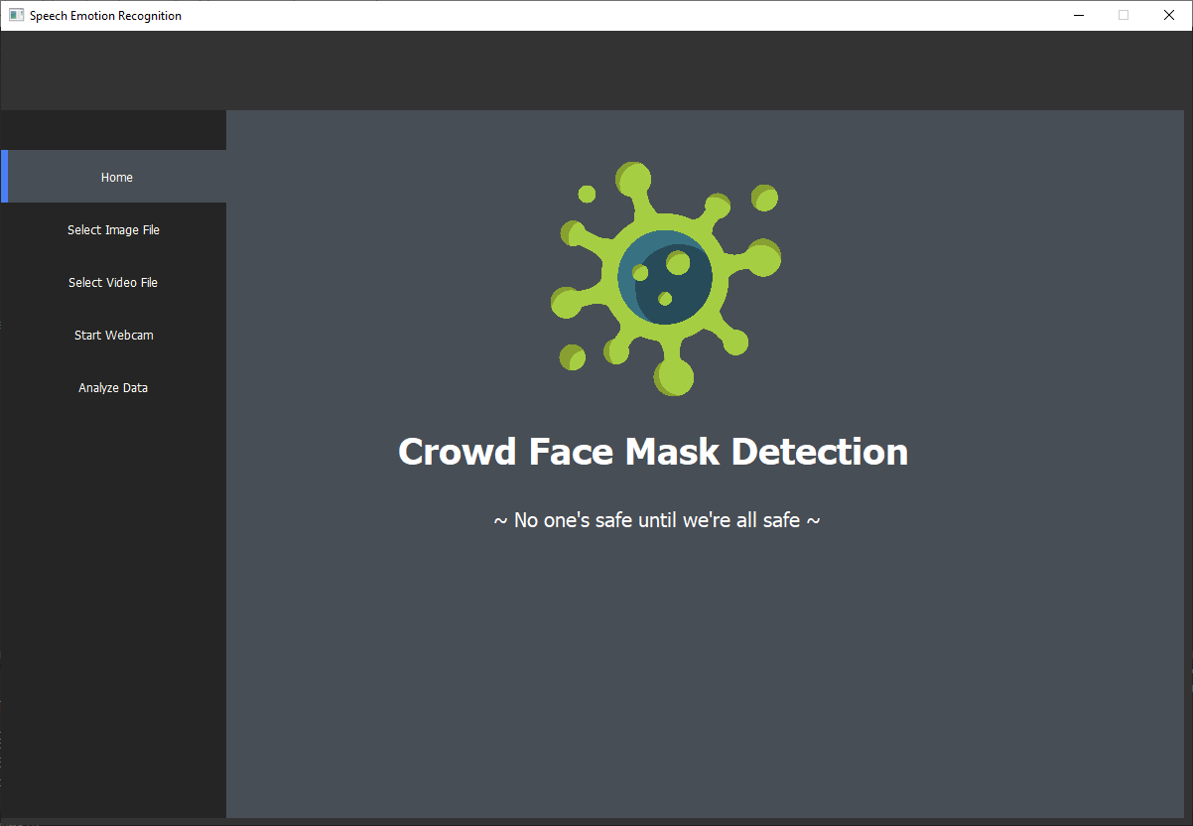

#### Image File

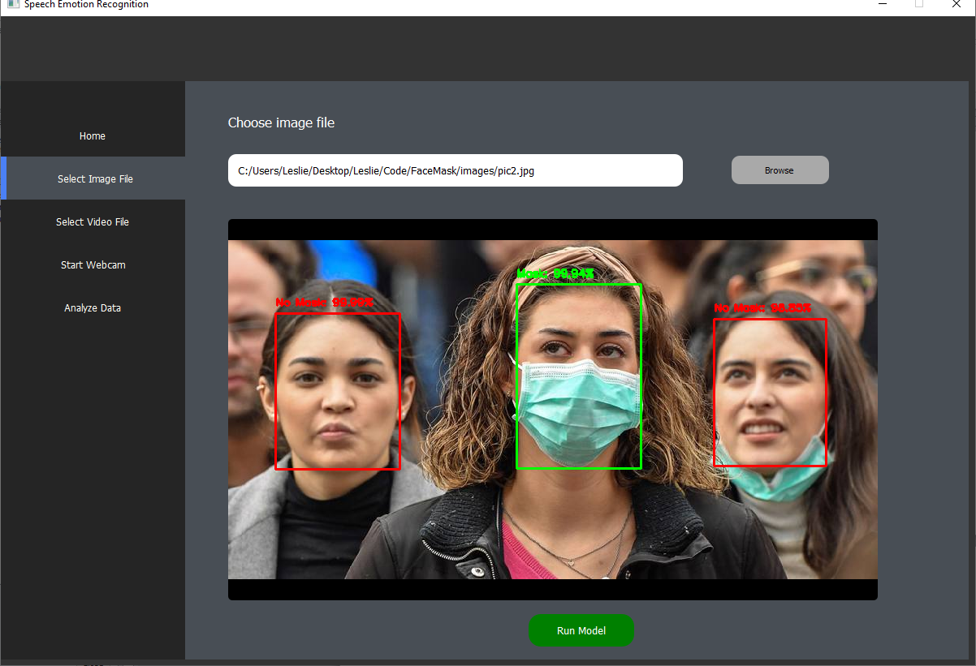

#### Webcam

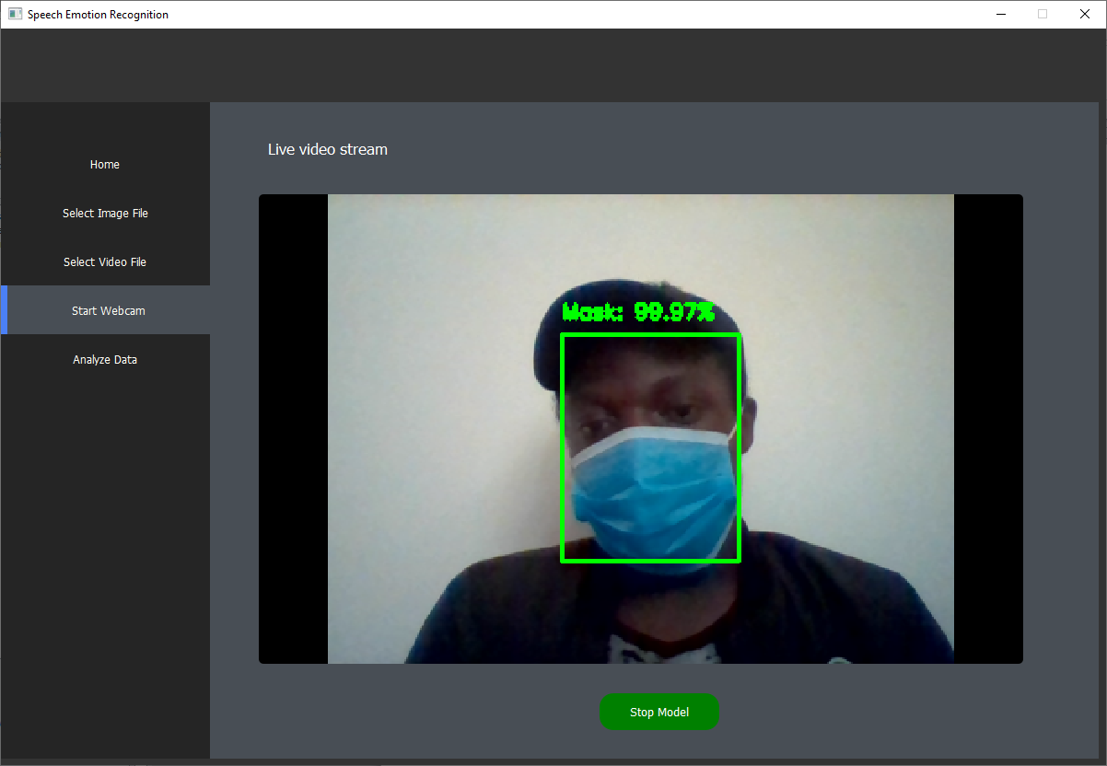

#### Analysis Screen

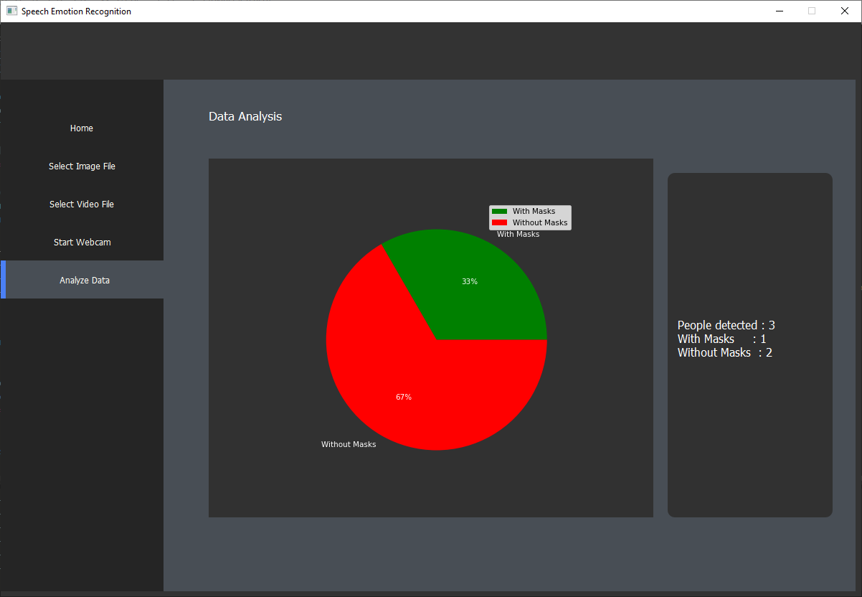

# CONCLUSION

The system is able to analyze visual data and predict whether or not the people present are wearing masks with a fairly high accuracy. It is also able to visually present this data to the user for analysis. The project therefore meets its set objectives.